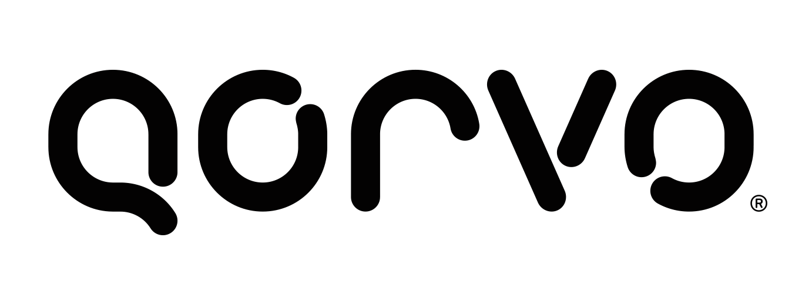
SUPPLIER INPUT FORM

Note: W-9 (Required for all U.S. suppliers.)

POs Mailed To:

Supplier Name:

Mailing Address:

City: State: Zip Code:

------------------------------------------------------------------------------------------------------------------------------------

Invoice Remit To:

Qorvo’s payment method preference is ACH for U.S. companies.
Wire transfer for companies outside the U.S. is required.

Please complete Qorvo’s Supplier EFT Enrollment Form or furnish bank details on company letterhead.

Complete the section below only if your company cannot participate in ACH payments.

Remit to Name:

Remit to Address:

City: State: Zip Code:

------------------------------------------------------------------------------------------------------------------------------------
Certificate of Insurance  Yes (Required for all suppliers performing work on site)
Self-Certification Form  Yes (Required for Hillsboro, Apopka & Costa Rica)

Taxpayer ID #: - Soc. Sec. # (1099) _____ - ____ - ________

Contact Name: Phone #:

Mobile #: Fax #:

PO Email Address:

Payment Terms: Net-45 Standard

Last updated: Sept. 12, 2016

